The Gini Coefficient and Introduction to Integration
Produced by Thomas J. Pfaff
sustainabilitymath.org

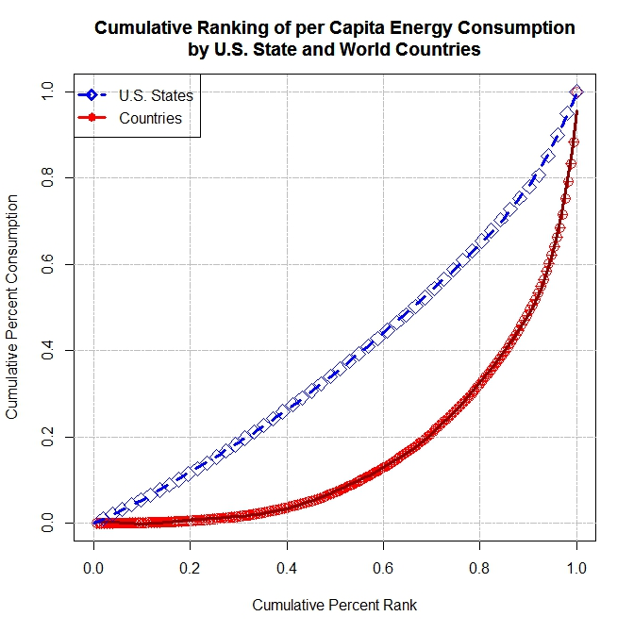
Note to Instructors (delete this before giving to students): Use this exercise before introducing Riemann sums as a motivation for wanting to find the area between curves. The last question leads them to this as the Gini coefficient is the area between equality y=x and a given Loren curve, divided by ½ to make it a percent. Once students can integrate we come back to this and calculate the respective Gini coefficients with the formula$gini coef=1-2\int_{0}^{1}{L\left(x\right)dx}$. In addition, for homework, you can ask student to find two Gini coefficients (use google), compare them, and explain what they tell us, so that student realize the Gini coefficient is something used in the real world to measure inequality. Overall, this assignment moves from differentiation ideas (in (5) the x=c value from MVT represents the split between under users and overuses) to integration. Once students can integrate, you can return to this project and have students find the Gini coefficients. Note that you will need some form of technology to solve higher order polynomial for zero. Lastly, the associated data exists in a spreadsheet and you can have student do the curve fitting, although excel will not fit a polynomial above 6th degree, but more importantly students might be interested in the states and countries that are over or under consumers.
Figure 1: The distribution of energy consumption in the U.S. (2014 data) and World (2011 data) can with Lorenz curve models ECus(x) = 7.2038917391x^6 -17.8551679663x^5+ 16.5816140612x^4-7.0654275059x^3+ 1.7077246274x^2 + 0.4260396828x and ECw(x) = 678.0352163746x^9-2796.251.

The distribution of energy consumption in the U.S. (2014 data) and World (2011 data) can be modeled by $ECus(x) = 7.2038917391x^{6} -17.8551679663x^{5}+ 16.5816140612x^{4}-7.0654275059x^{3}+ 1.7077246274x^{2}+ 0.4260396828x$ and$ECw\left(x\right)= 678.0352163746x^{9}-2796.2519054480x^{8}+4802.0852334478x^{7}-4441.8091503689x^{6}+ 2389.4054597788x^{5}-751.8800491391x^{4}+ 132.3874503758x^{3}-11.3747211453x^{2}+0.3569478992x$. To interpret these functions consider the example: $ECus\left(0.63\right)=0.47$means that the bottom 63% of states in the U.S. have per capita energy use in the bottom 48% of all states. The function $ECw\left(x\right)$ is similar and replaces countries for states. These functions are Lorenz curves and are commonly used in the context of income.
- Find out how much energy per person the bottom 75% and the bottom 95% of U.S. States consume. Also, find out how much energy per person the bottom 75% and the bottom 95% of countries of the world consume. Write sentences to explain the meaning of your answers in both parts. Based on your answers, does it appear as if there is more energy consumption inequality in the U.S. or countries in the world? Explain why your answer makes sense in economic terms. Would you expect there to be more inequality within states than by state?
- Should ECus(0)=0, ECus(1)=1, ECw(0)=0, and ECw(1)=1? Explain why or why not? How accurate are our models?
- What function for ECus(x) would represent perfect equality in U.S. per capita energy consumption by state? Would this be the same for ECw(x)? Explain your response in both cases.
- Why should there be a value x=c such that ECus(c) = 1 Answer the same question for ECw(x). (Hint: MVT.) Now find the value of c for both functions. (Hint: Technology will help.)
- In (4) the values of c have a significant real world interpretation. What is it?
- Sketch a graph of ECus(x) and the function representing perfect equality from (3). Sketch a similar graph but with ECw(x). Based on these graphs, make conjectures about how one might measure how much ECw(x) deviates from equality and eventually decide which function ECus(x) or ECw(x) represent greater inequality. Calculate this if you can.

