A Look at Atmospheric Methane
Produced by Thomas J. Pfaff
sustainabilitymath.org
Updated June 2020

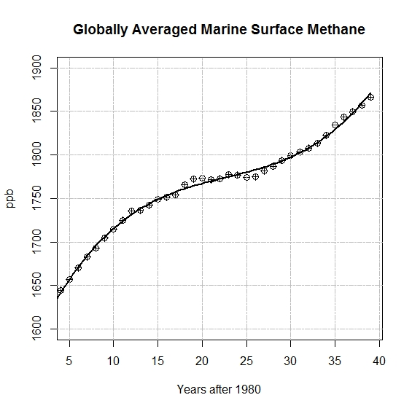
Figure 1 Data from https://www.esrl.noaa.gov/gmd/ccgg/trends_ch4/with a fitted curve.
Answer the following questions using the fitted curve, $y=1563.46410202131+ 22.86682158665x-0.89679836582x^{2}+0.01315317092x^{3}$, that is represented in Figure 1.
- Find a model with output Average MH4 in PPB and input years (or years after 1980). [Either delete this question or the figure, in which case provide the data.
- According to the model what will MH4 levels be in 2050?
- What is the rate of change of MH4 in 2019 (the last year of the data set) and what is the percentage rate of change?
- Assuming that MH4 levels continue to grow constantly at the 2019 rates, what will the MH4 levels reach in 2050?
Read https://www.epa.gov/ghgemissions/overview-greenhouse-gases#CO2 lifetime to answer the following questions.
- What confidence do you have in your predictions of atmospheric MH4? Hint: Consider the leveling off period in the methane data and information from the article.
- Methane is measured in ppb whereas CO2 is measured in ppm. It would seem then that since there is so much less atmospheric MH4 than C02 that it is not important. Why is this true or not?
- Globally, what is the largest source of MH4 emissions? What would we have to do to reduce the emissions from this source?
- In the U.S., what is the largest source of MH4 emissions? What would we have to do to reduce the emissions from this source?

