U.S. Coal Use
Produced by Thomas J. Pfaff
sustainabilitymath.org
Updated March 2023
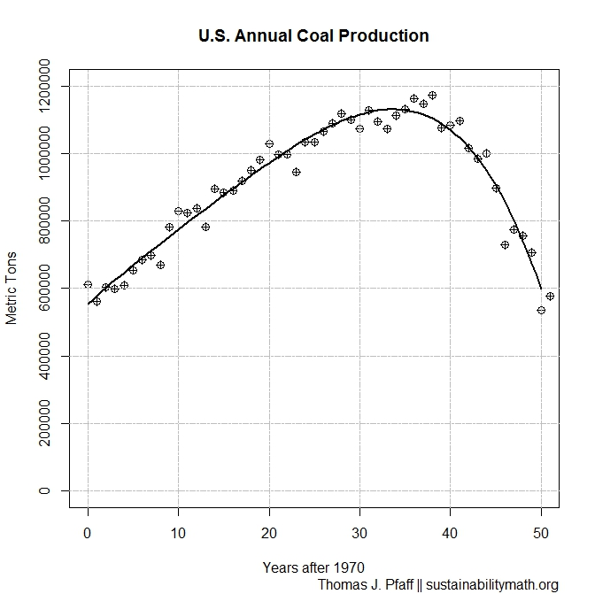
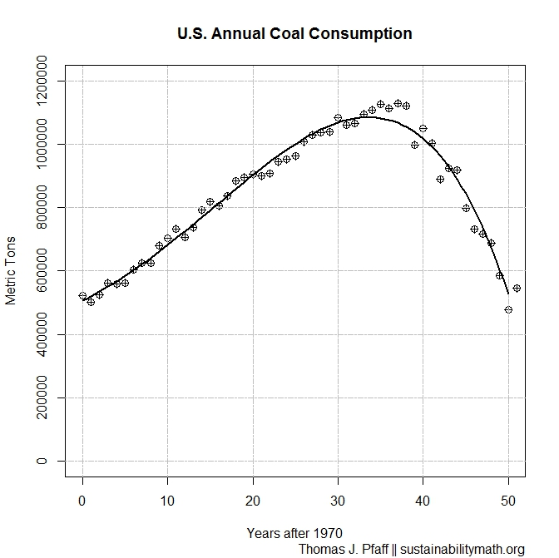
Figure 1: Annual U.S. coal consumption in metric tons with fitted curve $Con(x)=506277.225313905 + 13449.9175773923x +446.256437587651x^2 -1.39191623751436x^3-0.254735958081333x^4$

Figure 2: Annual U.S. coal production in metric tons with fitted curves, $Prod(x)=553134.350155957 + 24895.3680639253x -440.030527098651x^2 +20.7034466812164x^3-0.430029628755443x^4$
Answer the following questions using the fitted curve, $Con\left(x\right)=506277.225313905 + 13449.9175773923x +446.256437587651x^{2}-1.39191623751436x^3 -0.254735958081333x^4$represented in Figure 1 and, $Prod\left(x\right)=553134.350155957 + 24895.3680639253x-440.030527098651x^2 +20.7034466812164x^3 -0.430029628755443x^4$ represented in Figure 2.

- Find models for U.S. coal consumption and production. [Either delete this question or the figures, in which case provide the data.]
- According to the models when did consumption and production peak? Do the models accurately represent the data?
- When do the models predict that consumption and production will be 0 metric tons?
- How quickly was consumption and production decreasing in 2021 (last year of the data)?
- If we assume consumption and production continue to decrease at the 2021 rates, then when will they reach 0 metric tons?
- Summarize your results in a short paragraph and, in particular, include commentary regarding your predictions about when production and consumption will reach 0 metric tons. Incorporate information from this article in your summary: https://www.nytimes.com/2016/06/11/business/energy-environment/coal-production-decline.html How would you need to updated the NYT article given the information from this project? Has this article aged well or not?

