A Look at U.S. Oil
Produced by Thomas J. Pfaff
sustainabilitymath.org
Updated April 2023

Modeling U.S. Oil Production with a Normal Curve.
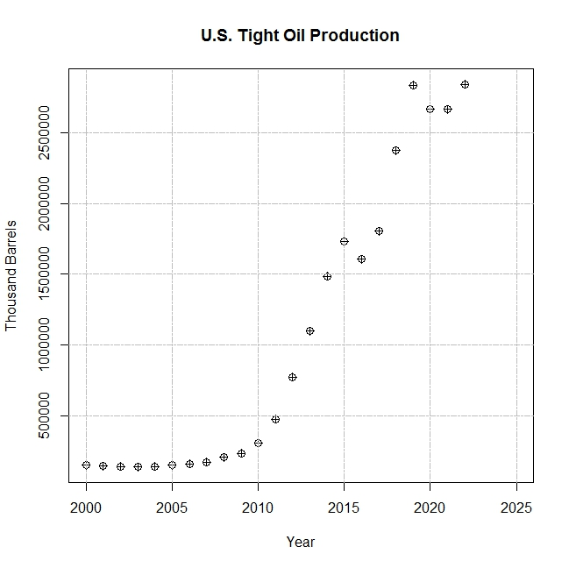
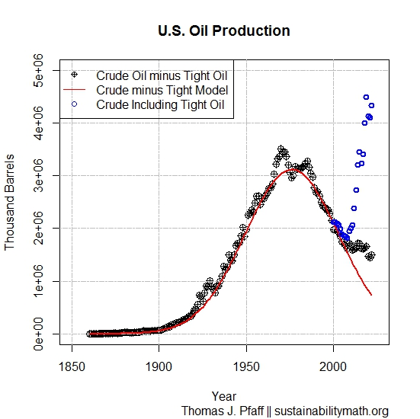

Figure 2 U.S. poduction of tight oil since 2000 in thousdand of barrels.
Figure 1 U.S. oil production in thoudand of barrels. Starting in 2000 the blue dots represent total crude oil including tight oil with the black dots represeting crude oil less tight oil. The red model is modeling crude oil less tight oil.

United States crude oil production followed a normal model until the early 2000s and then proceeded to have another peak, but the deviation from a normal model is due to the production of tight oil (also known as shale oil and requires hydraulic fracturing to extract). Figure 1 represents how tight oil has been responsible for increased oil production with Figure 2 representing tight oil production since 2000. Wikipedia provides a good overview of Hubbert’s modeling with a normal curve. If we remove tight oil, U.S. oil production can be modeled with a normal curve with a mean year of 1973 and a standard deviation of 27.164 years (using solver in Excel), although we should note that for the last 5 years or so convention oil production (crude oil less tight oil) has plateaued instead of decreased.
Questions
- According to the model, what percentage of our non-tight oil supply did we use from 1960 to 1990?
- According to the model, what percentage of our non-tight oil will we consume after 2021?
- What is the interquartile range for the non-tight oil model?
- In what year will we have consumed 95% of our non-tight oil?
- We have limited data on tight oil production, but as of now if you were to model it with a normal curve estimate the mean and standard deviation. Hint: One standard deviation from the mean is located at the inflection point.
- In a brief paragraph, predict the future of U.S. oil production.

