A Look at Wind Energy Production
Produced by Thomas J. Pfaff
sustainabilitymath.org
Updated June 2020

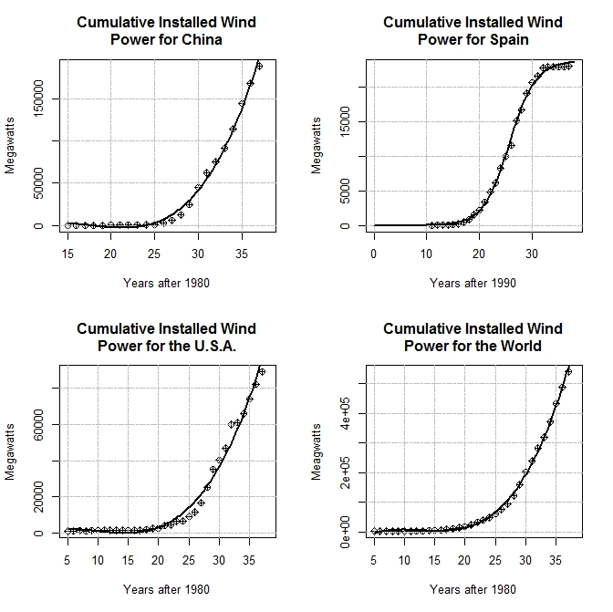

Figure 1 Cumulative installed wind power for three selected countries and the world with a fitted curve. The data represents installed capacity and not actual production. Note: These were chosen because they seemed interesting in some way and had good fits to the data.

Answer the questions using the following fitted curves for the graphs in figure 1. The goal here is to understand installed wind power. Recall that the input is years after 1980 with an output of watts.
$$World\left(x\right)=-62492.068837+17918.630913x-1498.963238x^{2}+39.548792x^{3}$$

$$USA\left(x\right)=216.160378179+1003.992127953x-142.925613207x^{2}+4.999548777x^{3}$$

$$Spain\left(x\right)=\frac{23787.005454719 }{1+e^{\left(\frac{ 25.679587156 -x}{2.455426786 }\right)}}$$

$$China\left(x\right)=-167603.08994918 +30071.22480925x-1731.43548842x^{2}+32.05043073x^{3}$$

- Find a model for the world, USA, Spain, and China for total cumulative installed wind power with input years after 1980. [Either delete this question or the figure and equations, in which case provide the data.]
- For each of the four models find the current (2018 which is the last year of the data) cumulative production, rate of change, and percentage rate of change. Summarize your results in a few sentences with a focus on comparing the three countries and the world. (BONUS) The values here are total watts but it would be better to compare per capita watts (why?) and so find the relevant population values and add that to your comparison.
- For the three countries, find models for the percent of world capacity they each represent. Repeat question 2 for these models.
- Which of the three countries is doing better at producing wind electricity? Consider total watts, per capita watts, rates of change, and wind energy relative to total electricity (See page 18, of the 2018 Annual Report https://community.ieawind.org/publications/ar)
- Investigate the feasibility of wind power meeting electricity needs for the selected countries and the world. Consider the data and the trends they represent.

