A Look at Global Ave Temp
Produced by Thomas J. Pfaff
sustainabilitymath.org
Updated March 2023
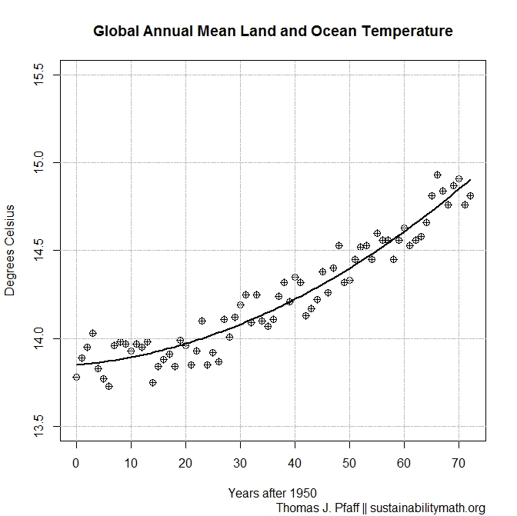
Figure 1 NOAA National Centers for Environmental information, Climate at a Glance: Global Time Series, published May 2020, retrieved on June 2, 2020 from https://www.ncdc.noaa.gov/cag/ Specifically, data for anomalies from 20th century for Land and Ocean from https://www.ncdc.noaa.gov/cag/global/time-series/globe/land/ytd/12/1880-2019 This page also contains data for Ocean and Land separately. Working with anomalies is preferable but may be harder for students to understand and so we use 13.9 deg C as the20th average temperature and add that to the anomaly. The baseline mean is from https://www.ncdc.noaa.gov/monitoring-references/faq/anomalies.php#mean More information about the preference of using anomalies is on this page and should be read (click FAQ).

Answer the following questions using the fitted curve, $T(x)=13.8493091447612 + 0.00279303700768105x + 0.000164386168920222x^{2}$, that is represented in Figure 1.

- Find a model with output Average Global Temperature and input years (or years after 1950) starting in 1950. [Either delete this question or the figure, in which case provide the data.]
- Use function composition to convert the T(x) function so that the output is Fahrenheit. Simplify your expression. Recall that F=9C/5 + 32.
- Based on the model what is the predicted global average temperature for 2025? 2050? 2100? How much of an increase is that for each of those years based on the current (use 2022, since that is the last year data was collected) average global temperature?
- What is the current (use 2022 which is the last year of data) rate of change of average global temperature? Based on this result, what is the predicted increase in global temperature by 2025? 2050? 2100? What will the average global temperatures be for those years? (in Fahrenheit).
- Explain why your two predictions are different.
- Use the information above to fill in the blanks (use Fahrenheit).
According to the model, if current temperature trends continue, in 2025 the average global temperature will be __________which is an increase of __________above the 2019 average temperature. On the other hand, if we assume that the rate of temperature increase remains constant at 2021 rates of __________, then the average global temperature will be __________ in 2025, which is an increase of __________above the 2021 average temperature.
- The projections of global temperature here are based on time series, but time isn't driving climate change. Sophisticated models of future climate are based on scenarios of human behavior. Consider Figure SPM.8a from the IPCC sixth assessment report (2021) https://www.ipcc.ch/report/ar6/wg1/figures/summary-for-policymakers/figure-spm-8). Which two projections for 2100 match closest to your two projections? Note the graph is in deg C, multiply by 9/5 to get a change in deg F. What are the underlying assumptions of each of these two scenarios? Go to the page that contains Figure 2. What impacts should we expect based on the warming trends we are predicting?
- Provide a question that you would like answered based on your work here.

