A Look at Solar Energy Production
Produced by Thomas J. Pfaff
sustainabilitymath.org
Updated March 2023

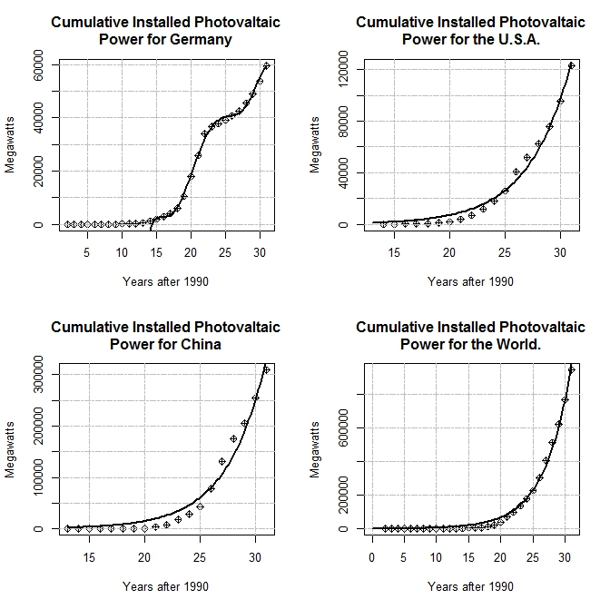
Figure 1 Cumulative installed photovoltaic power for three selected countries and the world with a fitted curve. The data represents installed capacity and not actual production. The average production throughout the world since 1993 is 62% of installed capacity. Note: These data sets were chosen because they seemed interesting in some way and had good fits to the data.

Answer the questions using the following fitted curves for the graphs in figure 1. The goal here is to understand installed solar energy. Recall that the input is years after 1990 with an output of megawatts.
$DEU\left(x\right)=-21166733.8180765 + 6112127.52535657x-721757.555494071x^2 +44582.162521006x^3-1519.13349612616x^4+27.0990468959568x^5-0.197925079642093x^6$ for x > 14

$$ROC\left(x\right)=53.0952893881596(1.32559801030574^x)$$

$$USA\left(x\right)= 40.2574939064205(1.29646334918397^x)$$

$$World\left(x\right)=574.111536081989(1.2712411799567^x)$$

- Find a model for Germany, China, USA, and the world for total cumulative installed photovoltaic power with input years after 1990. [Either delete this question or the figure and equations, in which case provide the data.]
- For each of the four models find the current (2021) which is the last year of the data) cumulative production, rate of change, and percentage rate of change. Summarize your results in a few sentences with a focus on comparing the three countries and the world. (BONUS) The values here are total megawatts but it would be better to compare per capita watts (why?) and so find the relevant population values and add that to your comparison.
- For the three countries, find models for the percent of world capacity they each represent. Repeat question 2 for these models.
- Investigate the feasibility of solar power meeting electricity needs for the selected countries and the world. Consider the data and the trends they represent. You can start here https://ourworldindata.org/electricity-mix for a look at the world and here https://www.eia.gov/electricity/data/browser/ for the U.S specifically.

