A Look at World Oil
Produced by Thomas J. Pfaff
sustainabilitymath.org
Updated March 2023

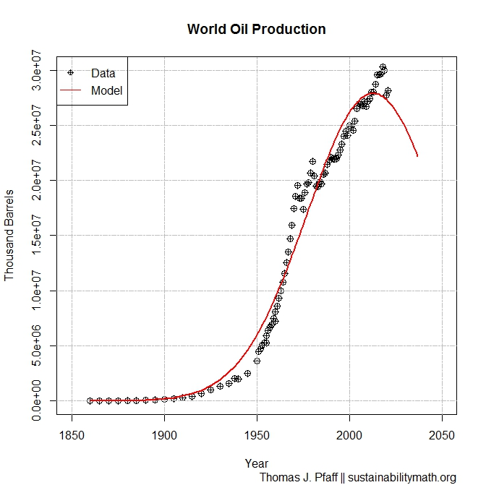
World Peak Oil and Normal Models

We can model world oil production with a normal distribution with assumptions on total recoverable oil. We will use two scenarios (see graphs). Scenario 1 assumes that there is 2.5 trillion barrels of total recoverable oil. This gives us a mean year of 2012 and a standard deviation of 35.76 years. Scenario 2 assumes that there is 3 trillion barrels of total recoverable oil. This gives us a mean year of 2021 and a standard deviation of 40.89 years.

Questions

- Which graph, top or bottom, represents scenario 1 and 2, and why?
- For each scenario what is the third quartile? Write a sentence or two comparing and explaining your results.
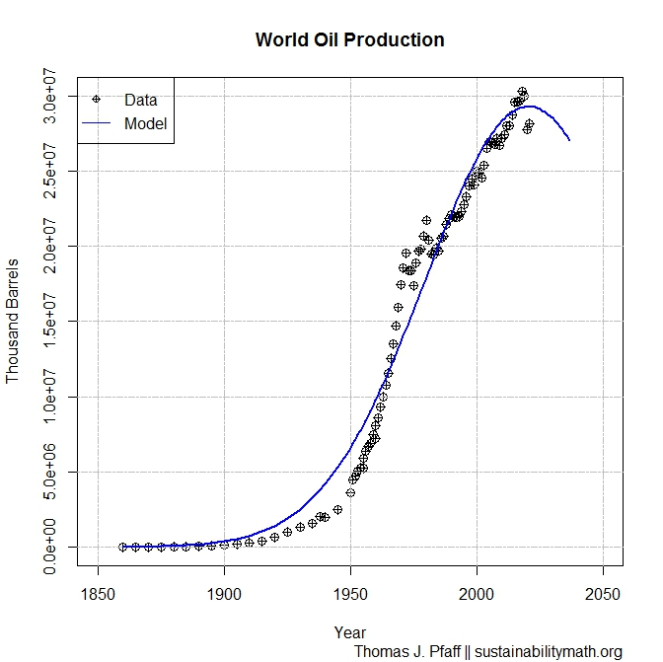
- For each scenario, what percentage of world oil will we have consumed by 2050? Write a sentence or two comparing and explaining your results.
- For each scenario, in what year will the world have consumed 95% of our oil? Write a sentence or two comparing and explaining your results.
- The increase of assumed recoverable oil between the two scenarios is 0.5 trillion barrels of oil. Is this a large or small difference between the two scenarios? Did this change have a large or small impact on the peak year and on your results in the questions above?

